Manav Rachna International Institute of Research and Studies

School of Computer Applications

Department of Computer Applications

Student Name | Mayank Dhankhar
Roll No | 24/SCA/BCA(AI/ML)/038
Program | BCA(AI&ML)
Subject | Python Programming
Semester | 3
Section/Group | C
Department | School of Computer Applications
Session / Batch | 2024-27
Faculty Name | Dr.Sakshi Gupta

Q1- Write a Python program to calculate number of days between two dates. Sample dates: (2014, 7, 2), (2014, 7,11)
Ans-
from datetime import datetime
date1 = input("Enter first date (dd-mm-yyyy): ")
date2 = input("Enter second date (dd-mm-yyyy): ")
d1 = datetime.strptime(date1, "%d-%m-%Y")
d2 = datetime.strptime(date2, "%d-%m-%Y")
diff = abs((d2 - d1).days)
print(f"Difference between the two dates is {diff} days.")
Output-

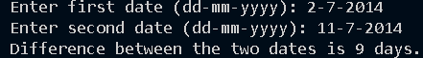

Q2- Write a Python program that accepts an integer (n) and computes the value of n+nn+nnn
Ans-
n = input("Enter an integer: ")
result = int(n) + int(n*2) + int(n*3)
print(f"The value of n+nn+nnn for n={n} is {result}")
Output-

Q3- Ask the user for a number. Depending on whether the number is even or odd, print out an appropriate message to the user.
Ans-
int(input("Enter the Number"))
if a%2 ==0:
print("This is an Even Number")
else:
print("This is an Odd Number")
Output=
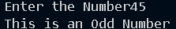

Q4- Write a Python program which accepts a sequence of comma-separated numbers from user and generate a listand a tuple with those numbers.
Ans-
numbers = input("Enter comma-separated numbers: ")
list_numbers = numbers.split(",")
tuple_numbers = tuple(list_numbers)
print("List :", list_numbers)
print("Tuple:", tuple_numbers)
Output-
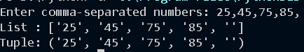

Q5- Write a Python program to calculate the sum of three given numbers, if the values are equal then return thrice of their
sum.
Ans-
def calculate_sum(a, b, c):
total = a + b + c
if a == b == c:
return 3 * total
else:
return total
x = int(input("Enter first number: "))
y = int(input("Enter second number: "))
z = int(input("Enter third number: "))
result = calculate_sum(x, y, z)
print("Result:", result)
Output
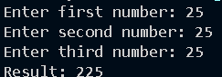

Q6- Write a Python program to test whether a passed letter is a vowel or not
def is_vowel(letter):
vowels = "aeiouAEIOU"
if letter in vowels:
return True
else:
return False
ch = input("Enter a letter: ")

if len(ch) == 1 and ch.isalpha():
if is_vowel(ch):
print(f"{ch} is a vowel.")
else:
print(f"{ch} is not a vowel.")
else:
print("Please enter a single alphabet only.")

Output-
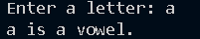

Q7- Take a list, say for example this one:
a = [1, 1, 2, 3, 5, 8, 13, 21, 34, 55, 89]
and write a program that prints out all the elements of the list that are less than 5.
Extras:Program-
- Instead of printing the elements one by one, make a new list that has all the elements less than 5 from this list in it and print out this new list.
b.Write this in one line of Python.
c.Ask the user for a number and return a list that contains only elements from the original list a that are smaller than that number given by the user.
Ans
a = [1,1,2,3,5,8,13,21,34,55,89]
for i in a:
if i < 5:
print(i)

b-
print([i for i in a if i<5])
c-
a = [1,1,2,3,5,8,13,21,34,55,89]
num = int(input("Enter a number: "))
result = [x for x in a if x < num]
print(result)

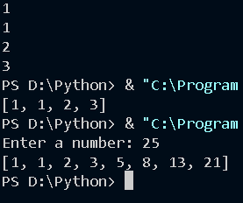

Q8- Create a program that asks the user for a number and then prints out a list of all the divisors of that number.
Ans- num = int(input("Enter a number: "))
divisors = []

for i in range(1, num + 1):
if num % i == 0:
divisors.append(i)

print("Divisors of", num, "are:", divisors)

Q9- Take two lists, say for example these two:
a = [1, 1, 2, 3, 5, 8, 13, 21, 34, 55, 89]
b = [1, 2, 3, 4, 5, 6, 7, 8, 9, 10, 11, 12, 13]
and write a program that returns a list that contains only the elements that are common between the lists (without duplicates). Make sure your program works on two lists of
different sizes.
Program-
a = [1, 1, 2, 3, 5, 8, 13, 21, 34, 55, 89]
b = [1, 2, 3, 4, 5, 6, 7, 8, 9, 10, 11, 12, 13]
common = list(set(a) &set(b))
print("Common elements:", common)

OUTPUT-

Q10- Ask the user for a string and print out whether this string is a palindrome or not. (A palindrome is a string that reads the same forwards and backwards.)
Ans-
string = input("Enter a string: ")
string = string.lower()
string = string.replace(" ", "")
if string == string[::-1]:
print("The string is a palindrome")
else:
print("The string is not a palindrome")

Output-
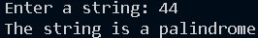

Q11- Let’s say I give you a list saved in a variable: a = [1, 4, 9, 16, 25, 36, 49, 64, 81, 100]. Write one line of Python that takes this list a and makes a new list that has only the even elements of this list in it.
Ans-
a = [1, 4, 9, 16, 25, 36, 49, 64, 81, 100]
even_elements = [element for element in a if element % 2 == 0]
print(“Even Elements are:”,even_elements)

Output-

Q12- Generate a random number between 1 and 9 (including 1 and 9). Ask the user to guess the number, then tell them whether they guessed too low, too high, or exactly right. (Hint: remember to use the user input lessons from thevery first exercise)
Ans-
import random

number = random.randint(1, 9)
guess = 0
count = 0

while guess != number and guess != "exit":
guess = input("Guess a number between 1 and 9 (or type exit): ")

if guess == "exit":
break

guess = int(guess)
count += 1

if guess < number:
print("Too low!")
elif guess > number:
print("Too high!")
else:
print("Exactly right!")
print("You guessed it in", count, "tries")
Output-
